**(20304) MCA 3 SEMESTER :: WEB PROGRAMMING**

**UNIT- I**

**INTRODUCTION TO HTML:** Introduction, Editing XHTML, First XHTML Example, W3C XHTML Validation Service, Headings, Linking, Images, Special Characters and Horizontal Rules, Lists, Tables, Forms, Internal Linking, Meta Elements.

**CASCADING STYLE SHEETS (CSS):** Introduction, Inline Styles, Embedded Style Sheets, Conflicting Styles, Linking External Style Sheets, Positioning Elements, Backgrounds, Element Dimensions, Box Model and Text Flow, Media Types, Building a CSS Drop – Down Menu, User Style Sheets, CSS 3.

**Unit-1**

**INTRODUCTION TO HTML:**

1. **Introduction:**

* HTML stands for HYPER TEXT MARKUP LANGUAGE.
* It is derived from SGML ( Standard Generalised Markup Language),
* It is developed by “TIM BERNER’S LEE” in 1990.
* It also called as Document designed language, Tag based language.
* HTML code can be written in any text editors like NOTEPAD,WORDPAD,EDIT-PLUS etc.
* HTML can be executed in any browsers like Mozilla, Firefox,Safari etc.
* HTML is a platform independent language.
* HTML is not a case sensitive.
* The pages are designed by using HTML, those are called as “WEB PAGES”.
* HTML web pages are static web pages.
* HTML code written in between two angular brackets. Those are called as TAGS. That’s why it is a tag based language.
* Tag is a keyword, There are two types of tags are available in HTML.Those are opening tags and closed tags.

Opening tags are represented as----< -------------------- >

Closing tags are represented as----- < /------------------ >

***Features of HTML:***

HTML has several features. The most important features are given below:

* HTML is used to create tables .
* HTML is used to create LISTS.
* HTML is used to create Hyperlinks.
* HTML is used to create different form elements.
* HTML is use to create Frames in HTML.
* It help us to create multiple web pages in a single web page.
* It is used to add GRAPHICS and easily add IMAGES in a webpage.

***TYPES OF TAGS IN HTML:***

There are three types of general tags in HTML. Those are

* Container tags
* NON-Container tags
* Special entities
* **Container tags:**

The tags which contains both opening and closing tags.

**Ex:** <html……............</html>

<head>..................</head>

<body>................. </body>

* **Non-Container tags:**

The tags which contains only opening but not closing tags.

**Ex:** <hr>------Horizontal ruler tag

<br>------ Break tag

* **Special entities:**

The entities are used for some special purposes only,which are enclosed with “&”(ampersand) symbol.

**EX:** &lt... Less than

&gt... Greater than

&nbsp..... NON breakable space.

1. **Explain HTML document structure?**

HTML stands for “HYPER TEXT MARKUP LANGUAGE”. It is mostly widely used to create web pages.

* Hyper text means web pages are linked together. The link available in a web page is called a Hyper Text.
* Markup language means ,generally HTML is s simply markup text document with tags than tell either web browser, how to structure is to display.

***STRUCTURE:***

HTML document contains two parts , namely HEAD part and BODY part.

**Syntax:**

<!—comments-->

<html>

<head>...........</head>

<body>...........</body>

</html>

In above structure ,

<html> tags encloses the complete document structure.<head> tag represents header.<body> tag represents the document body.

<!—comments-- > are used to describe the programs such a purpose name ,date and author details of the document are placed. Comments ignored by the web browser.

Head part contains the information like document name, address, logos etc. Head part contains a tag known as <title> tag.It defines the title of the webpage.Body part contains the information like running matter, and keeps the other HTML tags like <h1>,<p>,<table> etc.

**Ex:**

<!—sample program-->

<html>

<head> Rao’s Degree college</head><br>

<body>Best corporate degree college in Nellore district</body>

</html>

**Output:**

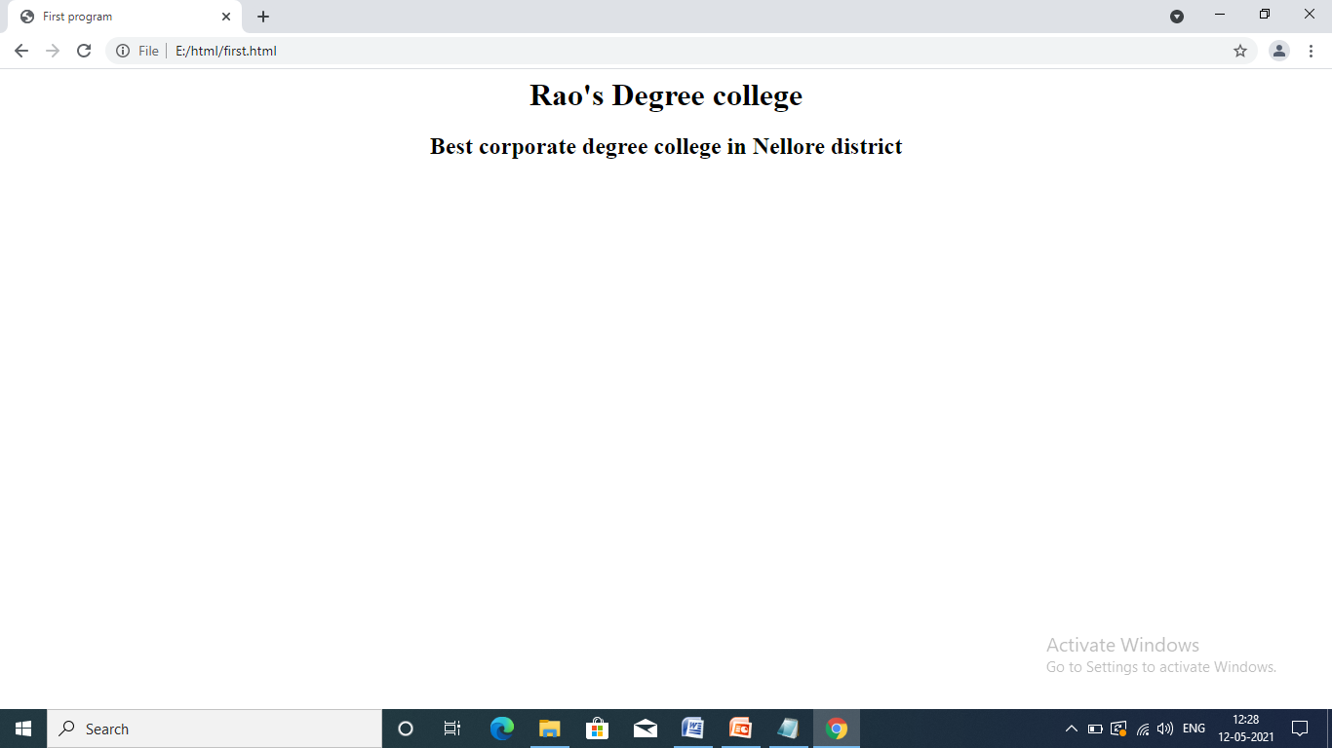

**NOTE:**

**ATTRIBUTE:**

Attribute means, provide additional information for a particular tag. The general form of attribute is as follows:

Attribute = ”value”

**Ex:** align=”center”

Color=”red”.

1. **W3C XHTML Validation Service:**

Programming Web-based applications can be complex, and XHTML documents must be written correctly to ensure that browsers process them properly. To promote correctly written documents, the World Wide Web Consortium (W3C) provides a validation service (validator.w3.org) for checking a document's syntax. Documents can be validated either from a URL that specifies the location of the file or by uploading a file to the site validator.w3.org/file-upload.html. Uploading a file copies the file from the user's computer to another computer on the Internet. Figure F.2 shows main.html (Fig. F.1) being uploaded for validation. The W3C's Web page indicates that the service name is MarkUp Validation Service, and the validation service is able to validate the syntax of XHTML documents. All the XHTML examples in this book have been validated successfully using validator.w3.org.

Figure F.2. Validating an XHTML document. (Courtesy of World Wide Web Consortium (W3C).)

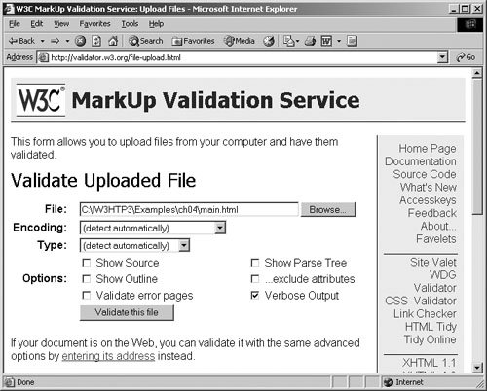

By clicking Browse..., users can select files on their own computers for upload. After selecting a file, clicking the Validate this file button uploads and validates the file. Figure F.3 shows the results of validating main.html. This document does not contain any syntax errors. If a document does contain syntax errors, the validation service displays error messages describing the errors.

Figure F.3. XHTML validation results. (Courtesy of World Wide Web Consortium (W3C).)

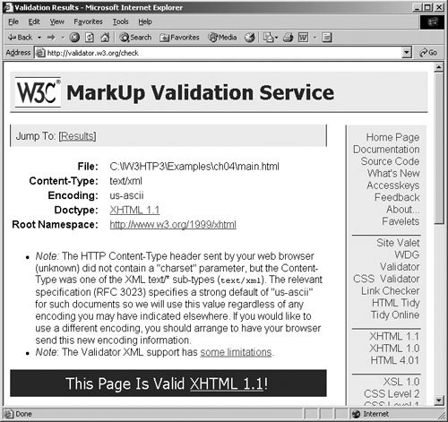

1. **HTML HEADERS:**

Some text in an HTML document may be more important than other text. Any document starts with a heading. You can use different sizes for your headings. HTML has six levels of headings, which use the elements **<h1>, <h2>, <h3>, <h4>, <h5>,** and **<h6>**. While displaying any heading, browser adds one line before and one line after that heading. Header element h1 is considered the most significant header and is typically rendered in a larger font than the other five headers. Each successive header element is typically rendered in a progressively smaller font.

All heading tags are container tags.

<h1>....................................</h1> Maximum size

<h2>....................................</h2>

<h3>....................................</h3> Default size

<h4>....................................</h4>

<h5>.....................................</h5>

<h6>.....................................</h6> Minimum size

**Ex:**

<html>

<head>

<title>

Internet and www how to write program

</title>

</head>

<body>

<h1>level 1 header</h1>

<h2>level 2 header</h2>

<h3>level 3 header</h3>

<h4>level 4 header</h4>

<h5>level 5 header</h5>

<h6>level 6 header</h6>

</body>

</html>

**Output:**

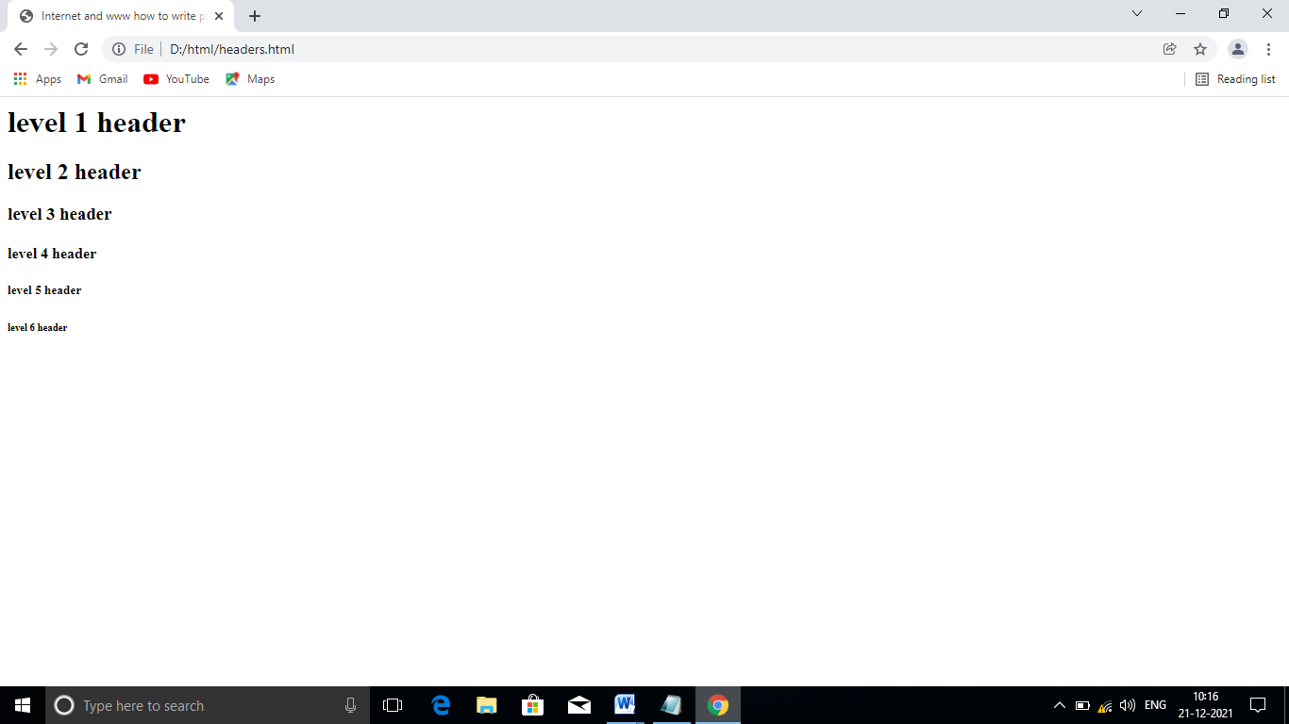

1. **HTML Linking or Internal linking:**

It is one of the most important feature in HTML. Using Hyperlinks we can establish a link between Webpages or websites..

Generally huge information in a single lengthy webpage is not an efficient way, because lengthy webpage will take longer time to get downloads. To reduce the downloading time of the webpage, the information should be distributed among multiple webpages, rather than a single webpage.

Hyperlinks can be created using a tag known as Anchor tag. It is represented as <a>. It is a container tag.

**Syntax:**

<a href=“url”>

....................

....................

</a>

In above syntax the attribute “href” means “HYPERREFERENCE”. It specifies the address of the webpage. The value ‘url’ means Uniform Resource Locator.

* ***Types of hyperlinks:***

There are four types of hyperlinks in HTML . They are:

1. Internal Hyperlinks
2. External Hyperlinks
3. Image Hyperlinks
4. Mailto Hyperlinks

* **INTERNAL HYPERLINKS:**

It creates a link from one position to another position with in the same webpage. Here we create source and target.

***Syntax:***

At source: <a href=“#linkname”> display text </a>

At target: <a name=“linkname”> display text </a>

* **EXTERNAL HYPERLINKS:**

It creates a link between different webpages or websites.

**Syntax:**

<a href=“url”>diplay text </a>

* **IMAGE HYPERLINKS:**

It creates a image hyperlink . When we click on image, it will open the webpage that is associated with the image.

**Syntax:**

<a href=“image.html”> <img src=“url”>diplay text </a>

* **MAILTO HYPERLINK:**

It is special type of hyperlink It contains e-mail address.

**Syntax:**

<a href=“mailto:email address”>Email address</a>

* **Example program for Internal Hyperlinks:**

<html>

<head>

<h1 align="center">Internal Hyperlinks</h1>

</head>

<hr align="center" size="20%" width="30%" color="green">

<body>

<h3 align="center">

<a href="#courses">Courses</a><br>

<a href="#batches">Batches</a><br>

<br><br>

<a name="courses"></a>

<b><u> courses offered</u></b>

<ol type="A">

<li>cloud computing</li>

<li>python</li>

</ol>

<br><br>

<a name="batches"></a>

<i><u> batches are</u></i>

<ul type="square">

<li>batchA</li>

<li>batchB</li>

</ul>

</h3>

</body>

</html>

***Output:***

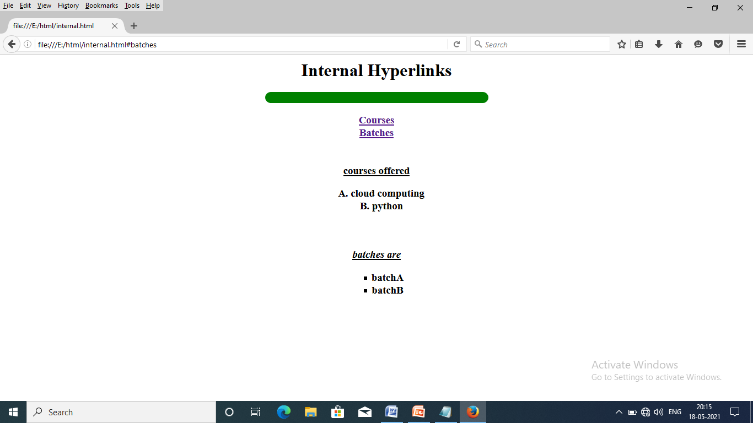

* **Example program for External Hyperlinks:**
* **Save as Externallink.html**

<html>

<head>

<h1 align="center">External Hyperlinks</h1>

</head>

<hr align="center" size="20%" width="30%" color="red">

<body bgcolor="yellow">

<h1 align="center">

<a href="course.html">courses</a><br>

<a href="batch.html">batches</a><br>

</h1>

</body>

</html>

* **Save as course.html**

<html>

<head>

<h1 align="center">External Hyperlinks</h1>

</head>

<hr align="center" size="20%" width="30%" color="red">

<body bgcolor="pink">

<h1 align="center">

<b><u> Courses Offered</u></b><br>

<ol type="A">

<li>Java</li>

<li>Python</li>

<li> Dot net</li>

<li>Ajax</li>

<li>RMI</li>

</ol>

</h1>

</body>

</html>

* **Save as batch.html**

<html>

<head>

<h1 align="center">External Hyperlinks</h1>

</head>

<hr align="center" size="20%" width="30%" color="red">

<body bgcolor="violet">

<h1 align="center">

<i><u> Batches are</u></i><br>

<ul type="circle">

<li>BatchA</li>

<li>BatchB</li>

<li>BatchC</li>

<li>BatchD</li>

<li>BatchE</li>

</ul>

</h1>

</body>

</html>

***Output:***

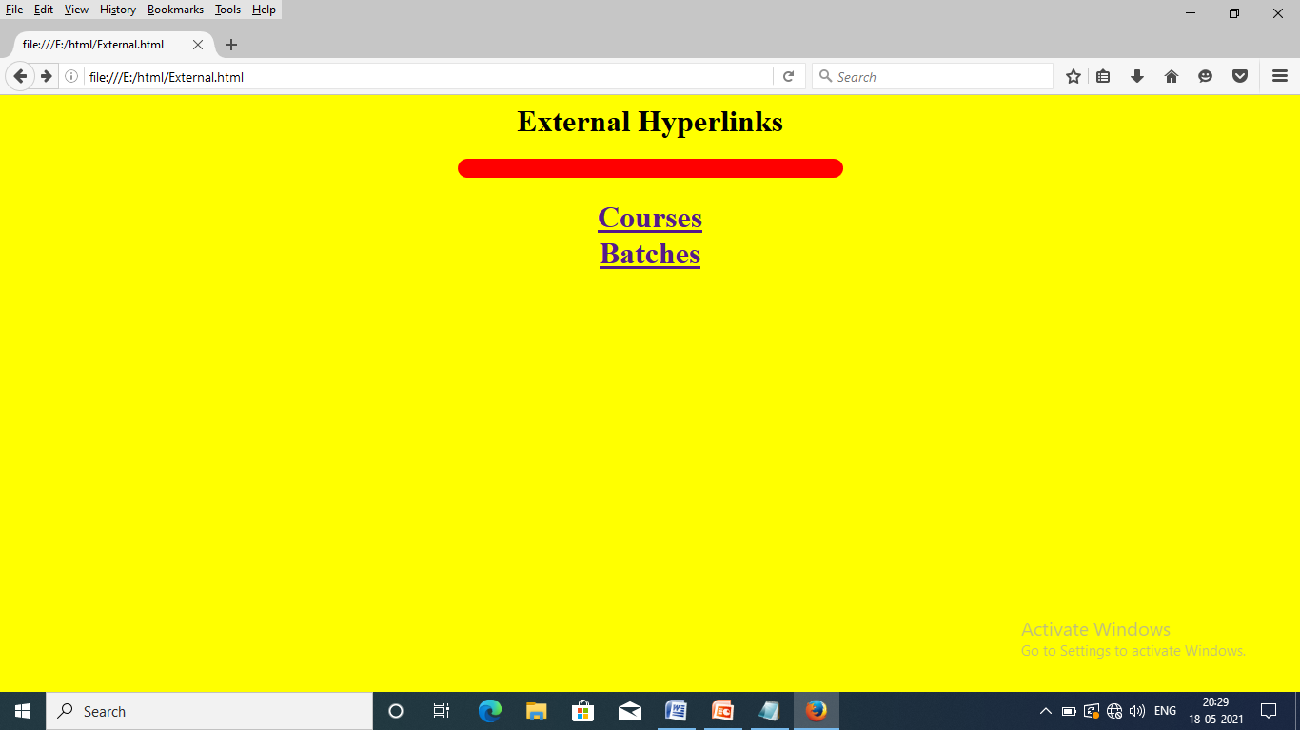

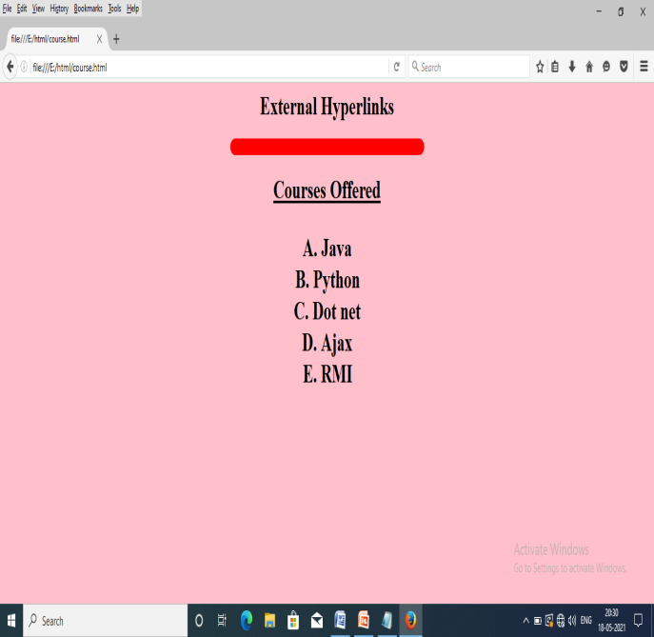 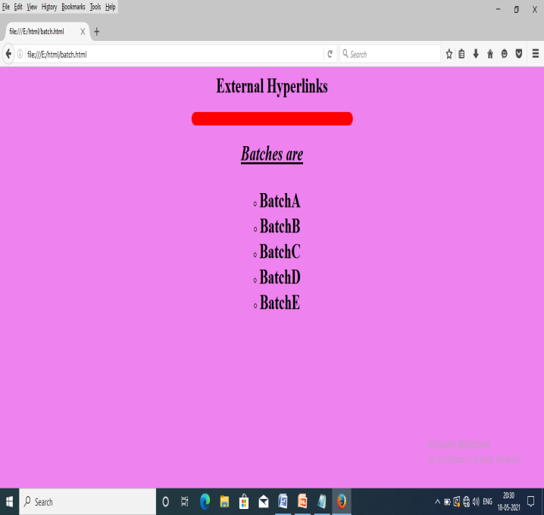

1. **Explain Horizontal Ruler (HR tag) tag in HTML?**

Horizontal ruler tag is used to separate the content in an HTML document. It is represented as <hr>. It is a non container tag. It contains number of attributes , those are color,size, align and width.

|  |  |  |
| --- | --- | --- |
| **ATTRIBUTE** | **VALUE** | **DESCRIPTION** |
| Align | Left/center/right | It specifies the alignment of the Hr tag |
| Color | Color name/ Hexadecimal coding | It specifies the color of the HR tag |
| Size | Value in percentages | It specifies the height of the  HR tag |
| Width | Value in percentages | It specifies the width of the HR tag |

***syntax:***

<hr color=“ color name” align=“left/center/right” size=“value in percentage”

width=“ value in percentage”>

**Example:**

<html>

<head>

<h1 align="center">Rao's degree college</h1></head>

<hr color="red" size="30%" width="30%" align="center">

<body>

<h1 align="right"> web technology</h1>

<hr color="#cc66ff" size="30%" width="30%" align="right">

<h1 align="right"> Horizontal ruler tag</h1>

<hr color="#dd77bb" size="30%" width="30%" align="left">

<h1 align="left">It contains number of attributes </h1>

</body></html>

***Output:*** 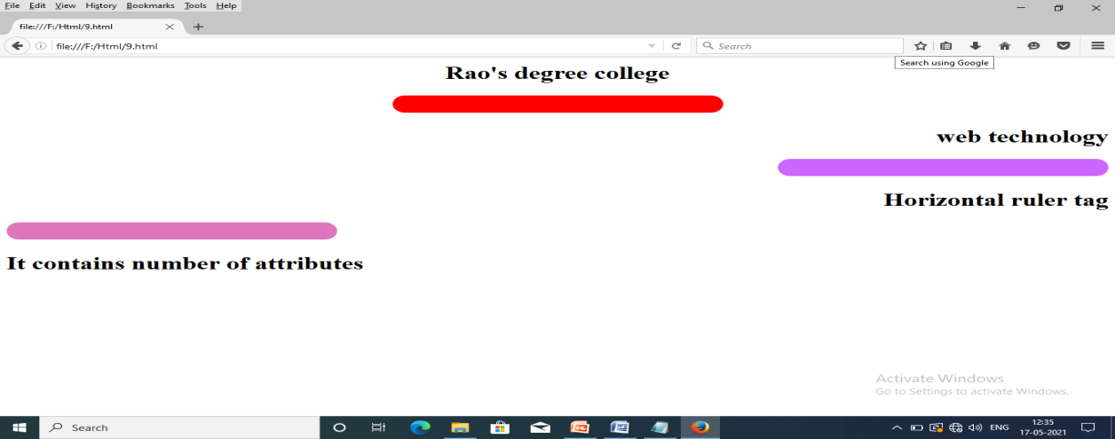

1. **HTML images:**

Most web pages contain both and images.The design and appearance of a web page is very attractive by using images. In html images are defined with a non-container tag known as **“img”** tag. It represented as <img >. This tag along with a special attribute known as “src (source)”.The value of this attribute is “URL”( uniform resource locator). The three most popular image formats used by web developers are Graphics Interchange Format (GIF), Joint pictures Experts Group(JPEG), and Portable Network Graphics(PNG) images.

***Syntax: <img src=“url”>***

The image tag contains number of attributes. Some of them are:

* **Height and width:** This attribute defines the height and width of a image in pixels. The general form is:

<img src=”url” height=”value in pixels” width=”value in pixels”>

* **Alt:** This attribute defines the alternate text to the image. The general form is;

<img src=”url” alt=”alternate text”>

* **Border:** This attribute defines the border of the image. We can specify border thickness in terms of pixels using this attribute. The general form is:

<img src=”url” border=”value in pixels”>

* **Float:** By using this attribute the image moves from one side to another side I,e., left to right or right to left. The general form is:

<img src=”url” style=”float:left/right”>

* **Background-image :** By using this attribute to add a background image on a web page.But, specify the background-image property on the body section. The general form is:

<body style=”background-image:url(‘image address’)”>

**Syntax:**

<img src=“url” height=“value in pixels” width=“value in pixels” border=“value in pixels” style=“float:left/right”>

***Example:***

<html>

<head> </head>

<body style=“background-image:url(‘flower1.jpg’)”>

<h1 align=“center”>

<font color=”blue”>

Image example

</font>

</h1>

<img src=“flower2.jpg” height=“100” width=“50”

border=“value” style=“float:right”>

</body>

</html>

***Output:***

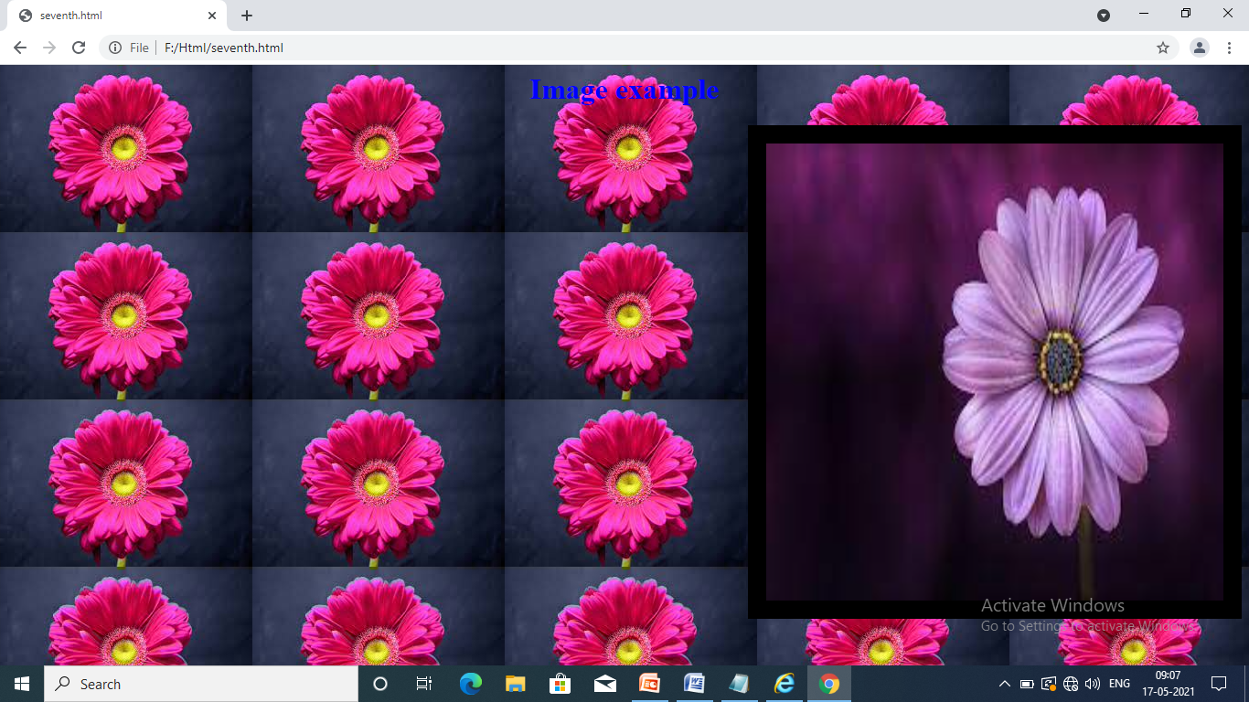

1. **HTML special characters:**

HTML contains other special characters, which can be expressed as either character entity references or numeric character references.

The reserved characters must be replaced with character entities. The characters that are not present as HTML elements use entities. The advantage of using an entity name is easy to remember. The disadvantage of using an entity name is browsers may not support all entity names, but the support browsers number is good.

Some of the HTML entities are:

|  |  |  |
| --- | --- | --- |
| **ENTITY NAME** | **DESCRIPTION** | **RESULT** |
| &lt | Less than | **<** |
| &gt | Greater than | **>** |
| &amp | Ampersand | **&** |
| &quot | Double quotations | **“** |
| &apos; | Single quotation | **‘** |
| &nbsp | Non breakable space | **Empty space** |
| &cent | cent | **₵** |
| &yen | yen | **¥** |
| &copy | copy | **©** |
| &reg | Registered trade mark | **®** |

***Ex:*** <html>

<head>

HTML Entities

</head>

<body>

<h1 align=”center”>&lt HTML<br>

&gt HTML<br>

&quot HTML<br>

&apos; HTML<br>

&copy HTML<br>

&reg HTML<br>

&yen HTML<br>

&cent HTML<br>

&amp HTML

</h1>

</body>

</html>

***Output:***

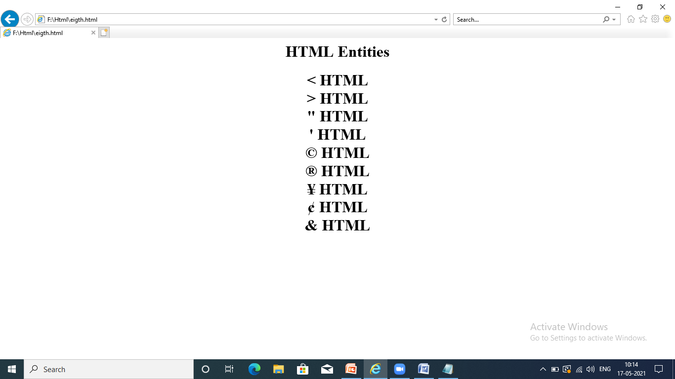

1. **HTML character tags:**

The tag is applied to an individual character is known as “ character tags”. There are two types of character tags in HTML. They are:

* Logical character tags
* Physical character tags.
* ***Logical character tags:***

This tag describes how the text is being used not necessarily, how it is formatted. Some of the logical character tags are:

* **Citation tag:** This tag is used to make the text in italic face. It is represented as <cite> . It is a container tag.

<cite>...............</cite>---🡪Italic

* **Delete tag:** This tag is used to display the text with a line through it> It is represented as <del>. It is a container tag.

<del>...............</del>.---------🡪strike

* **Insert tag:** This tag is used to display the text with underline. It is represented as <ins>. It is a container tag.

<ins>...........</ins>------------🡪underlined

* **Emphasize tag:** This tag is used to display the in italic face. It is represented as <em>. It is a container tag.

<em>.........</em>------------🡪Italic

* **Strong tag:** This tag is used to make the text in strong face. It s represented as <strong> . It is a container tag.

<strong>............</strong>------🡪Bold.

* ***Physical character tags:***

This tag controls how the characters are formatted. some of the physical character tags are:

* **Bold tag:** This tag is used to make the text in Bold face. It is represented as <b>. It is a container tag.

Bold tag--🡪 <b>--------------</b>.

* **Italic tag:** This tag is used to make the text in Italic face. It is represented as <i>. It is a container tag.

Italic tag--🡪 <i>---------------</i>

* **Underline tag:** This tag is used to set underline to the text. It is represented as <u>. it is a container tag.

Underline tag🡪 <u>-------------</u>

* **Subscript tag:** This tag is used to set the text as subscript.(base/suffix).It is represented as <sub>. It is a container tag.

Subscript tag-🡪 <sub>----------</sub>

* **Superscript tag:** this tag is used to set the text as superscript.(power/prefix). It is represented as <sup>. It is a container tag.

Superscript tag-🡪 <sup>----------</sup>

* **Big tag:** This tag is used to make the text in bold face. It is represented as <big>. It is a container tag.

Big tag🡪 <big>...............</big>

* **Strike tag:** This tag is used to display the text with a line through it. It is represented as <s>. it is a container tag.

Strike tag-><s>.................</s>

***Ex:***

<html>

<head>

<h1 align="center">character tags</h1>

</head>

<hr>

<body>

<h1 align="center"><font color="#dd6633">

<i> web technology</i><br>

<cite>web technology</cite><br>

<b> HTML</b><br>

<strong>HTML</strong></br>

<em> BCA</em></br>

<u>web programming</u><br>

<ins>Web programming</ins><br>

<del> Rao’s college</del><br>

<s>Rao’s college</s><br>

h<sub>2</sub>O<br>

x<sup>2</sup>+y<sup>2</sup>.

</font></h1></body></html>

**Output:**

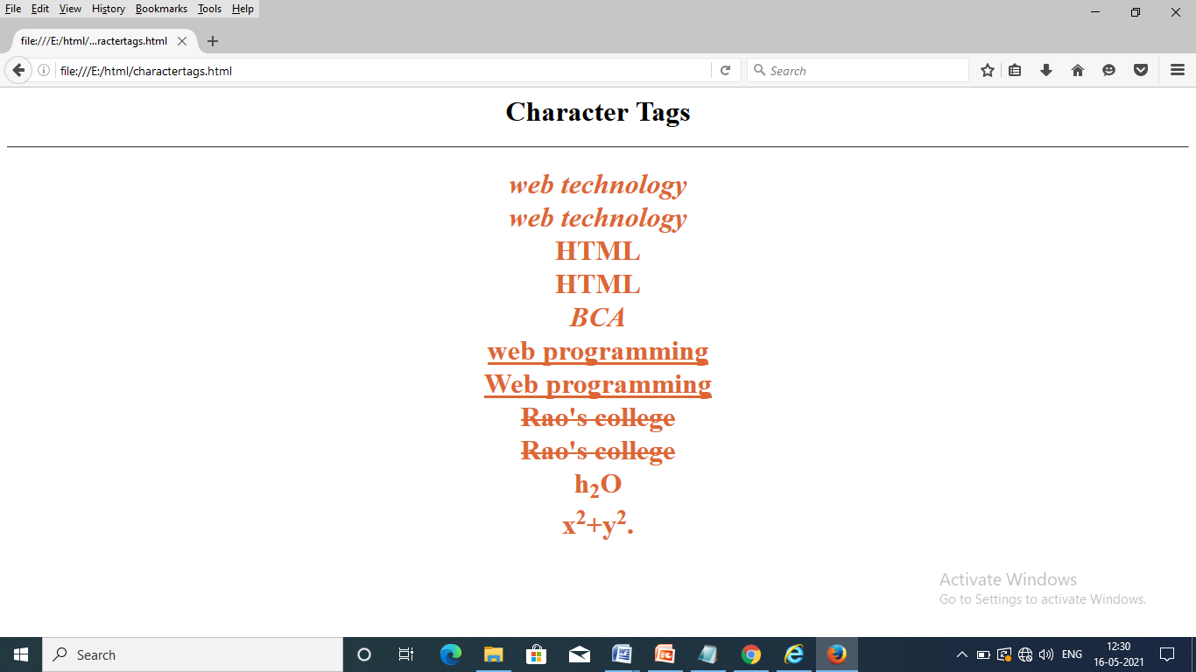

1. **HTML Lists:**

A list is a collection of elements, which is having a particular order . There are three types of lists in HTML. They are:

* Ordered list
* Unordered list.
* Nested list.
* ***Ordered list:***

An ordered list is a list of elements, which is having a particular sequence. In Html we can create a ordered list by using a tag known as <ol>. It is a container tag , along with this tag use a sub item list tag known as <li>( list item tag).

***Syntax:***

<ol>

<li>------- </li>

<li>--------</li>

<li>---------</li>

</ol>

By default <ol > tag displays digits only. But the user wants other than digits i.e, alphabets ,roman numbers . We use a special attribute called , **“type”.**

**Syntax:**

<ol TYPE=“ A/a/I/i”>

<li> --------------</li>

<li>--------------- </li>

<li>-------------- </li>

</ol>

* ***Unordered list:***

An Unordered list is a list of elements, which is having without any sequence. In Html we can create a unordered list by using a tag known as <ul>. It is a container tag , along with this tag use a sub item list tag known as <li>( list item tag).

***Syntax:***

<ul>

<li>------- </li>

<li>--------</li>

<li>---------</li>

</ul>

By default <ul > tag displays disc symbols only. But the user wants other than disc symbols i.e, square, circle ,use a special attribute called , **“type”.**

**Syntax:**

<ul TYPE=“square/circle”>

<li> --------------</li>

<li>---------------</li>

<li>-------------- </li>

</ol>

* ***Nested List:*** A list contains another list is known as Nested list. By using this feature we can present a list and sublist on the web page.

**Syntax:** <ol>

<li>............</li>

<li>...........</li>

<li>

<ul>

<li>.....</li>

<li>......</li>

..............

...................

</ul>

</li>

....................................

.....................................

</ol>

**Ex:**

<html>

<head>

<h1 align="center" style="background-color:pink"><font color="red">HTML

Lists</font></h1> </head> <hr>

<body bgcolor="yellow">

<font color="green">

<h1>

<b><u>Inventor:</u></b> Charles Babbage<br>

<i><u>parts:</u></i><ul type="square">

<li>Input Device</li>

<li>CPU

<ol type="A">

<li>ALU</li>

<li>CU</li>

<li>MU</li>

</ol>

</li>

<li>Output Device</li>

</ul> </font></h1>

</body>

</html>

***Output:***

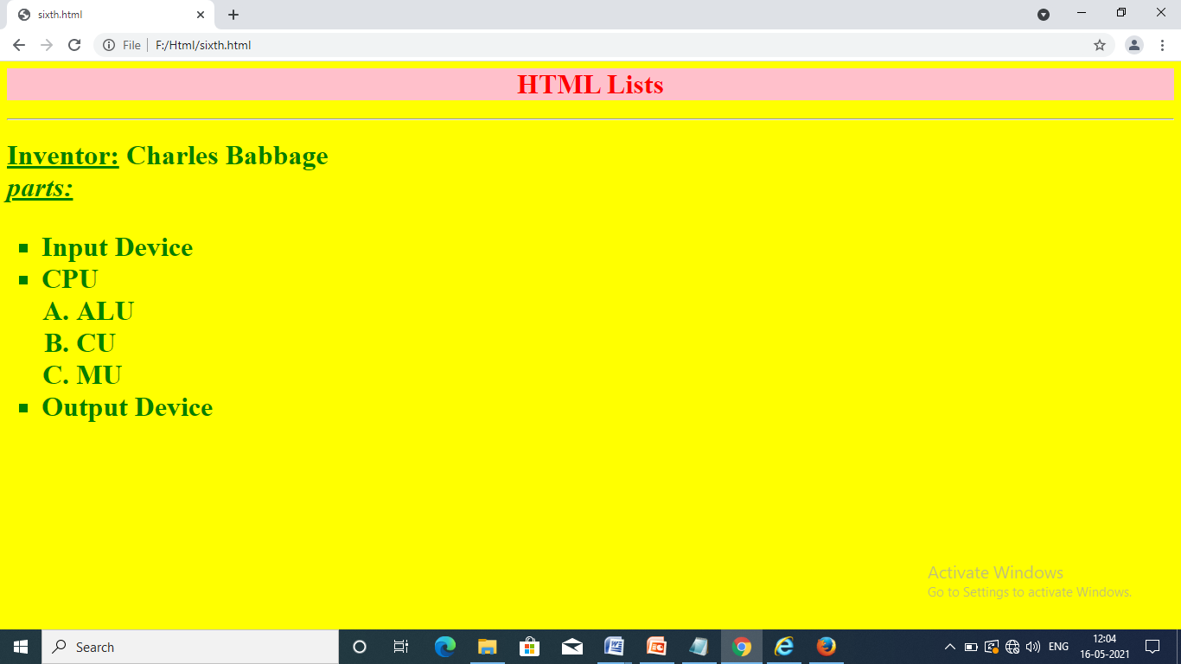

1. **HTML Tables:**

Table is a collection of rows and columns. Using tables we can present the data in row wise and column wise. Using tables to provide an information in an organised way.The following tags are used to create tables in an HTML document.

* Table tag
* Table row tag
* Table data tag
* Table heading tag
* Caption tag
* ***Table tag:***

It is a primary tag. This tag is used to create tables in a webpage.It is represented as <table>. It is a container tag . It contains following attributes:

* **Border :** This attribute specifies the border of the table.
* **Bordercolor :** This attribute specifies the bordercolor of the table
* **Align :** This attribute specifies the alignment of the table
* **Bgcolor :** This attribute specifies the background-color of the table
* **Cellpadding :** This attribute provides the space between the cell content and the table cell.
* **Cellspacing :** This attribute provides the space between the two cells in a table.

**The general form is:**

<table border=”value” bordercolor=”colorname/coding” align=”left/center/right”

Bgcolor=”colorname/coding” cellpadding=”value” cellspacing=”value”>

………………….</table>

* ***Table row tag:***

This tag is used to set a row on the table. It is represented as <tr>. It is a container tag. It contains bgcolor attribute.

**Syntax:** <tr bgcolor=“colorname”>

* ***Table data tag:***

This tag is used to store data on the particular row of a table. It represented as <td>. It is a container tag. It contains two special attributes, those are ROWSPAN and COLSPAN. The rowspan attribute defines the space between two or more rows and colspan attribute defines the space between two or more coloumns in a table.

**Syntax:** <td align=“center/left/right rowspan=“value” colspan=“value”>

* ***Table Heading tag:***

This tag is used to create a heading for the row in a table . It is represented as <th>. It is a container tag.

**Syntax:**

<th align=”left/center/right”>…………………..</th>

* ***Caption tag :***

This tag is used to create a small headings for the table. It is represented as <caption>. It is a container tag.

**Syntax:** <caption>…………………………………..</caption>

***Syntax:*** **Structure of a TABLE:**

<caption> --------</caption>

<Table>

<tr>

<th>.......</th>

<th>......</th>

...............

................

</tr>

<tr>

<td>.......</td>

<td>......</td>

...............

................

</tr>

<tr>

<td>.......</td>

<td>......</td>

...............

................

</tr>

<tr>

<td>.......</td>

<td>......</td>

...............

................

</tr>

</table>.

***Ex:***

<html>

<head></head>

<body>

<h1 align="center"><caption>Student Table</caption></h1>

<table border="4" bordercolor="red" align="center" cellpadding="10"

cellspacing="5" bgcolor="#ff4466">

<tr bgcolor="yellow">

<th>sno</th>

<th>sname</th>

<th>marks</th>

</tr>

<tr>

<td>101</td>

<td> suresh</td>

<td>99</td>

</tr>

<tr>

<td>102</td>

<td>tirupal</td>

<td>100</td>

</tr>

<tr>

<td>103</td>

<td> Gopi</td>

<td>98</td>

</tr>

</table>

</body>

</html>

**Output:**

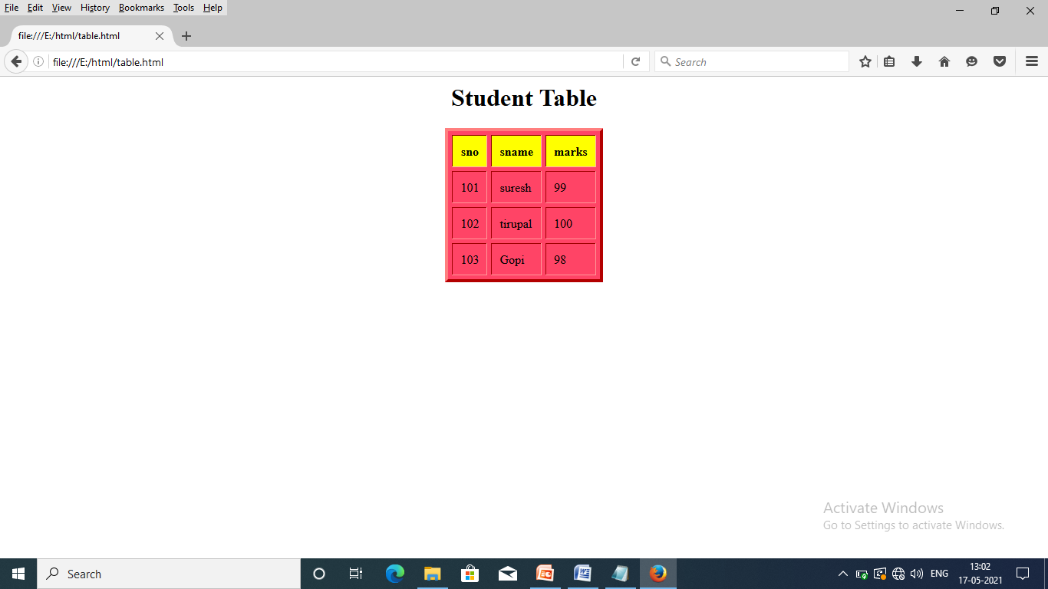

* **NESTED TABLES IN HTML:**

Nested table is a table. It consists of a table inside another table.. By using nested tables, the web page provides visually interesting and how the potential of introducing errors depend on its nesting nature.

Nested table always placed between the table data tag.. The below example create a table inside another four tables. Each table consist of rows and coloumns.

***Ex:***

<html>

<head>

<h1 align="center">Nested Tables</h1></head>

<body>

<table border="4" bordercolor="red" align="center">

<tr>

<td align="center"> First Row</td>

<td>

<table border="8" bordercolor="blue" align="center">

<tr>

<td>First Row</td>

</tr>

<tr>

<td>Second Row</td>

</tr>

</table>

</td>

</tr>

<tr>

<td>

<table border="6" bordercolor="green" align="center">

<tr>

<td>

<ul>

<li>Merit</li>

<li> Dull</li>

<li>Average</li>

</ul>

</td>

</tr>

</table>

</td>

<td>

<table border="8" bordercolor="yellow" align="center">

<tr>

<td> B.Sc & BCA students</td>

</tr>

</table>

</td>

</tr>

</table>

</body>

</html>

***Output:***

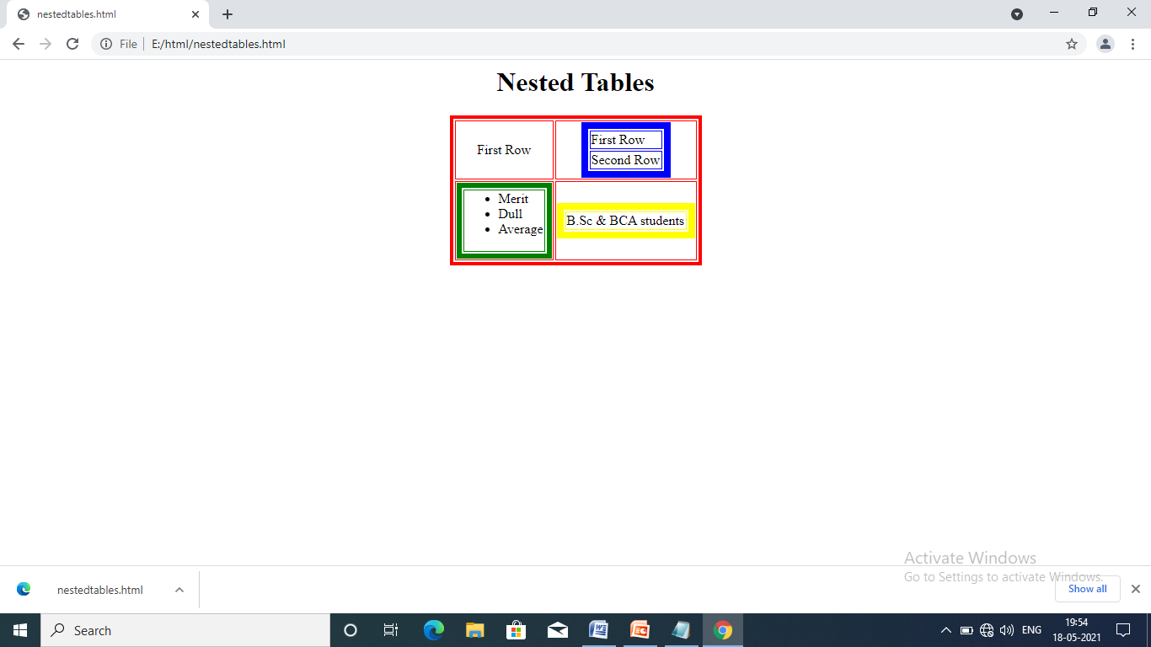

1. **HTML Forms:**

Forms are used to add an element of interactions to a website. If we want to use forms check with the system administrator of your server, that allows to run CGI script after the user fills the form. The input is directed to the program running on the web server. In most cases a particular control called submit is used to gather the information and send it to the proper designation on your website.

The following tags are used to create forms in HTML.

* Form tag.
* Input tag.
* ***FORM TAG:***

This tag contains interface elements such as textbox, password field, radio buttons, check box, action buttons, combobox and textarea.

* ***INPUT TAG:***

This tag defines a form control for the user to enter input. This tag must be along with in the form tag.

The following attributes are used in input tag:

* **Type:** It specifies the type of the form control
* **Name:** It specifies the name of the form control
* **Size:** It specifies the size of the form control
* **Value:** It specifies the value of the form control

***Syntax:***

<form>

<input type=“form element type” name=“name” value=“value” size=“size”>

--------------

---------------

----------------

</form>

**The form elements are:**

* **Textbox:**

It is a rectangular shaped field in which the user can enter the text . The general form is:

<input type=”textbox” name=”any name” value=”any value” size=”any size”>

* **Password field:**

This element is used to display the invisible characters. The general form is:

<input type=”password” name=”any name” value=”any value” size=”any size”>

* **Radio buttons:**

It is also called as group of buttons, from which only one can be selected at a time, that means pushing button forced, currently selected or deleted. The general form is:

<input type=”radio” name=”any name” value=”any value” size=”any size”>

* **Checkbox:**

It is represented by an icon , that the user can select or deselect by clicking on it. By using checkbox, the user can easily spevify all preferences. The general form is:

< input type=”checkbox” name=”any name” value=”any value” size=”any size”>

* **Combobox:**

This element is used to specify the list of items from the list.The following tags are used to create the combobox element.They are <select> and <option>. The general form is:

<select name=”any name” value=”any value” size=”any size”>

<option>...................</option>

<option>....................</option>

......................................

......................................

......................................

</select>.

* **Action buttons(SUBMIT AND RESET):**

When the user clicks “submit” button, the value that have been enclosed one form into the program that process the form> The general form is:

<input type=”submit” name=’any name” value=”submit” size=”anysize”>

The reset button is used to allow the user to clear all the inputs that they have for entered into the forms. The general form is:

<input type=”reset” name=”any name’ value=’any value” size=”any size”>

* **Textarea:**

This element defines the form controls , for the user to enter multiline input tet. This element contains two special attributes, those are “rows” and “cols”. The general form is:

<textarea name=”any name” rows=”value” cols=”value”>

</textarea>

*NOTE:*  The form elements combobox and textarea are container tags.

Remaining all form controls are non-container.

***Ex:***

<html>

<head>

<h1 align="center">Rao's Degree College</h1>

<h2 align="center">Nellore</h2>

</head>

<hr align="center" size="20%" width="30%" color="red">

<body bgcolor="blue">

<form>

<p align="center">

Enter name &nbsp &nbsp &nbsp &nbsp &nbsp &nbsp <input

type="textbox" name="tb1"><br><br>

Enter Father's name <input type="textbox" name="tb2"><br><br>

Enter password &nbsp &nbsp <input type="password"><br><br>

select gender <input type="radio" name="r1"> Male &nbsp &nbsp &nbsp

&nbsp &nbsp &nbsp <input type="radio" name="r2"> Female<br><br>

select hobbies<input type="checkbox" name="cb1"> singing

&nbsp &nbsp &nbsp &nbsp &nbsp &nbsp

<input type="checkbox" name="cb2" > dancing<br><br>

Select Qualification <select >

<option>ssc</option>

<option>Inter</option>

<option> degree</option>

<option>pg</option>

</select><br><br>

Describe ur self <textarea name="ta" rows="20" cols="20">

</textarea><br><br>

<input type="submit" value="Submit"> &nbsp &nbsp &nbsp &nbsp

&nbsp &nbsp <input type="reset" value="Reset">

</p>

</form>

</body>

</html>

**Output:**

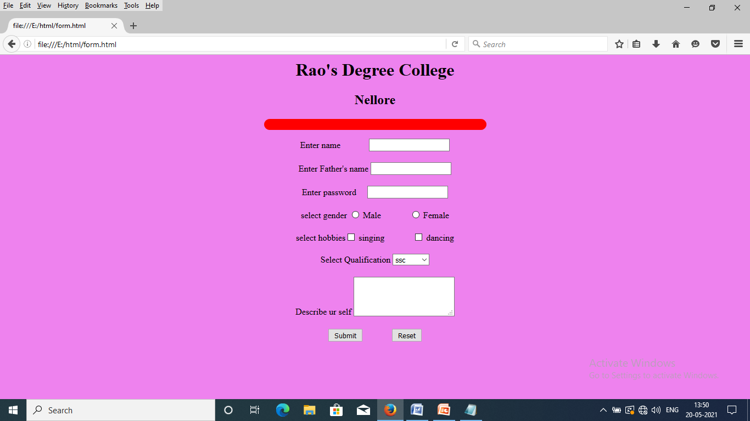

1. **HTML meta elements:**

Search engines are used to find web sites. They usually catalog sites by following links from page to page and saving identification and classification information for each page. One way that search engines catalog pages is by readingthe content in each page’s **meta** elements, which specify information about a document.

Two important attributes of the meta element are **name**, which identifies the type of meta element, and **content**, which provides the information search engines use to catalog pages.

**Ex:**

<html>

<head>

<title>

Internet and www, How to program

</title>

<meta name="keywords" content="webpage, design, feed back, form, contacts,links,

frame details">

<meta name="description" content=" This website will help you learn the basics of

HTML">

</head>

<body>

<h1> Welcome to our site</h1>

<p> we have designed this site to teach about the wonders of <em>HTML</em>.<em>

HTML</em> is used to represent the data on the internet. <em> HTML </em> takes

the advantage of XML strict syntax to ensure well -formedness, soon you will know

about many of the great new features of <em>HTML</em>.</p>

<p>Have a fun with the site !</p>

</body> </html

**Output:**

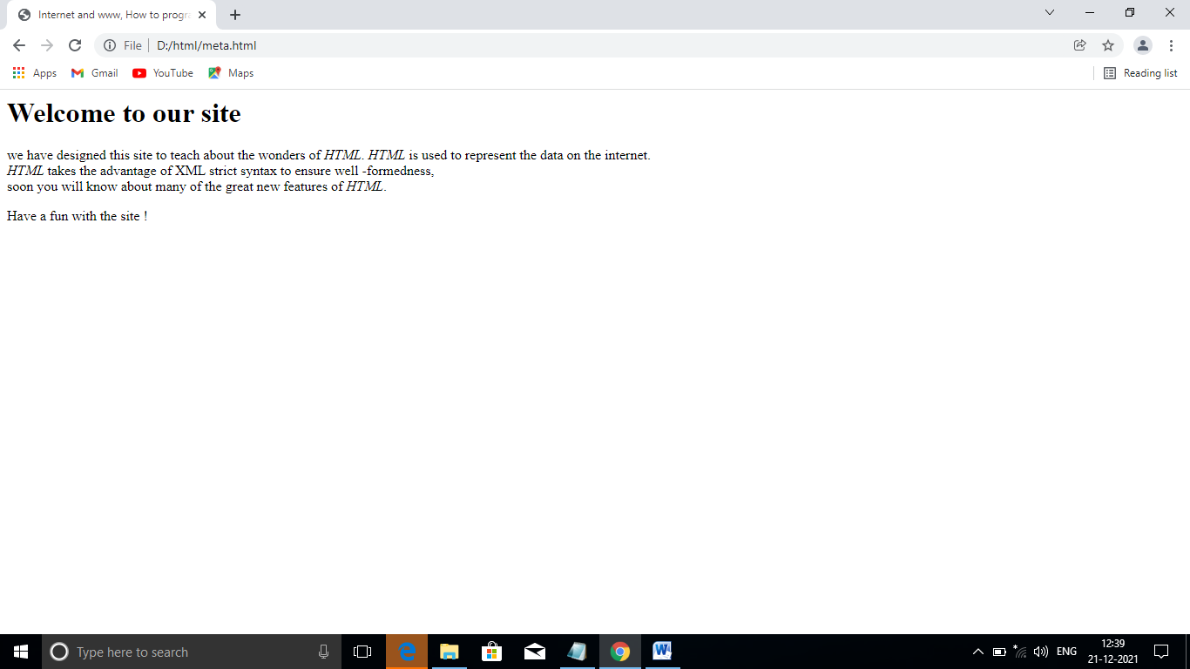

In above program “keywords” demonstrates a meta element. The content attribute of such a meta element provides search engines with a list of words that describe a page.

In above program “ description” demonstrates a meta element. The content attribute of such a meta element provides a three- to-four –line description of a site.

**CASCADING STYLE SHEETS (CSS):**

1. **Introduction:**

CSS means “cascading style sheet”. Generally HTML is used for designing the WebPages. But it is a poor page formatting. We use CSS it is used to improve the page formatting.

A style sheet can be simply a set of instructions, that can be applied a piece of text. There are three mechanisms by which we can apply own styles to our HTML document.

* The style can be defined with in basic HTML.
* Styles can be defined in head section and can be applied to entire document.
* Styles can be defined in external files called “Linking style sheets”. Which can be used in any document by including the style sheet through a “URL”.

CSS syntax has two parts namely SELECTOR and DECLARATION.

***Syntax:*** selector {declaration; declaration ;......................}

HTML element {poperty1:value1; property2:value2:...............}

**EX:** h1 { text-align: center; color : red;..................}

In above syntax, selector consists of HTML element. Declaration consists of property and value. In css two or more declarations, they are separated by semicolon(;). Property and values are separated by colon (:) symbol.

* ***Advantages of CSS:***
* **CSS saves time:** We can write CSS code once and then reuse the same code in multiple times, to create number of web pages frequently and easily.
* **Page load faster:** Just write once css rule of a HTML tag and it applies all appearances of the webpage, that’s why the webpage reducing the downloading time.
* **Easy maintenance:** By using css simple changes can be done and also update the web pages automatically.
* **Global web standards:** It is good ideas to start using css in all HTML web pages, to make them all features are supported in all browsers.
* ***Disadvantages of CSS:***
* **Bowser compatibility:**

1. The two main browsers IE and Netscape navigator having various levels of complaints with the style sheets. That means some style sheet features are supported and some are not.
2. Css comes in different levels. Those are css1, css2 and css3. This has resulted in confusion among developers and web browsers. One type of css should be enough.

* **Different properties and values in CSS:**

CSS means “cascading style sheet”. Generally HTML is used for designing the WebPages. But it is a poor page formatting. We use CSS it is used to improve the page formatting.

In CSS there are number of properties and values which are used to format the webpage. Those are:

* Properties related to font.
* Properties related to text.
* Properties related to colors.
* Properties related to boxes/borders.
* **PROPERTIES RELATED TO FONTS:**

The properties which are used for the fonts are given below:

* **Font-family**: This property is used to change the different types of fonts , to the text. The general form is:

**Syntax:** font-family: family name

Ex: font-family: times new roman

* **Font-style :** This property is used to change the style of the font. The general form is:

**Syntax:** font-style: normal/italic

Ex: font-style: italic

* **Font-weight :** This property is used to set font weight to the text. The general form is:

**Syntax:** font-weight: bold/lighter/normal

Ex: font-weight: bold

* **Font-size :** This property is used to set size of the font. The general form is:

**Syntax:** font-size: small/medium/large

Ex: font-size: medium

* **PROPERTIES RELATED TO TEXT:**

The properties which are used for the Text are given below.

* **Text-decoration:** This property is used to decorate the text. The general form is:

**Syntax:** text-decoration: underlined/overlined

**Ex:** text-decoration: underlined

* **Text-align:** This property is used to alignment of the text. The general form is:

**Syntax:** text-align: left/center/right

**Ex:** text-align:right

* **Text-transform:** This property is used to transform the text in to lower and upper cases. The general form is:

**Syntax:** text-transform: lowercase/uppercase

**Ex:** text-transform:uppercase

* **PROPERTIES RELATED TO COLORS:**

The properties which are used for the COLORS are given below

* **Color:** This property is used to set colors to the text. The general form is:

**Syntax:** color: color name/ hexadecimal coding

**Ex:** color :red (or) #dd6644

* **Background- color:** This property is used to set background-color to the text. The general form is:

**Syntax:** background-color: color name/coding

**Ex:** background-color: green or #aa88ff

* **Background-image:** This property is used to set background-image for the whole document. The general form is:

**Syntax:** background-image:url

**Ex:** background-image: sunset.jpeg

* **PROPERTIES RELATED TO BOXES/BORDERS:**

The properties which are used for the boxes/borders are given below.

* **Border-style:** This property is used to set the border style to the text: The general form is:

**Syntax:** border-style : dotted/doubled/solid/none

**Ex:** border-style: dotted

* **Border-color :** This property is used to set border-color to the text. The general form is:

**Syntax:** border-color: color name/ coding

**Ex:** border-color: pink

* **Border-width :** This property is used to set border-width to the text. The general form is:

**Syntax :** border-width : thin/thick/medium.

**Ex:** border-width: thick

**2. Different CSS styles in HTML Or Different types CSS styles in HTML:**

CSS means “cascading style sheet” . Generally HTML is used for designing the Webpages. But it is a poor page formatting. We use CSS it is used to improve the page formatting.

There are three types of CSS styles in HTML. They are:

* Inline style sheets.
* Embedded style sheets.
* External linking style sheets.

1. ***INLINE STYLE SHEETS:***

These are the styles which are applied to a specific line of the tag or individual element of an HTML document.

In inline style sheet using **“ style”** as a attribute that can be applied to an individual element of HTML like <p>,<h1>,<table>etc.

**Syntax:**

**<htmltag style=“property1:value1;**

**property2:value2; property3:value3:...................” >**

**Ex: <h1 style=”text-align:center;color:red”>**

**Ex**: <html>

<head>

<h1 align=”center”>

Inline Style Sheets</h1>

</head> <body>

<h1 style="font-family:Bahnschrift SemiBold;font-style:italic;

font-weight:bold;font-size:large;text-align:center;

color:magenta;background-color:yellow">

Web Technologies</h1>

<h1 style="text-align:center;text-transform:uppercase;

text-decoration:underline;border-style:dotted;

border-color:violet">

B.Sc/BCA students</h1>

<h1 style="color:red;background-color:pink">

cascading style sheets</h1>

<h1 style="border-color:blue;border-style:dotted;

border-width:thick;text-align:center">

Advanced HTML</h1>

</body></html>

***Output:***

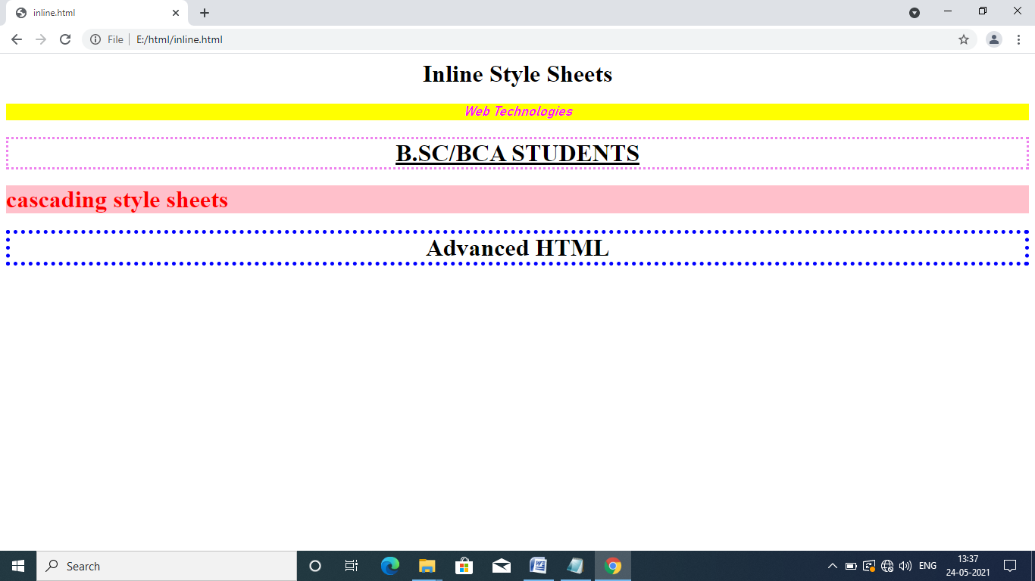

1. ***EMBEDDED STYLE SHEETS:***

Embedded means combined . These are the styles which can be applied to entire document. Here we use “STYLE: as a tag and it is placed in HEAD section of the HTML document.

***Syntax:***

**selector { declaration ; declaration ;......................}**

**HTML element { poperty1:value1; property2:value2:...............}**

**EX: h1 { text-align:center; color : red;..................}**

**Program:**

<html>

<head>

<style>

h1{text-align:center;color:red;font-weight:bold}

h2{text-decoration:underline;text-transform:uppercase;background-

color:#44dd77}

p{border-style:dotted;border-color:#77dd33}

</style>

</head>

<body>

<h1> Embedded Stylesheet</h1>

<h2>second style sheet</h2>

<p> CSS types in DHTML</p>

<h1>web technologies</h1>

<p> Rao's Degree College </p>

<h2>Create smart people</h2>

</body>

</html>

**Output:**

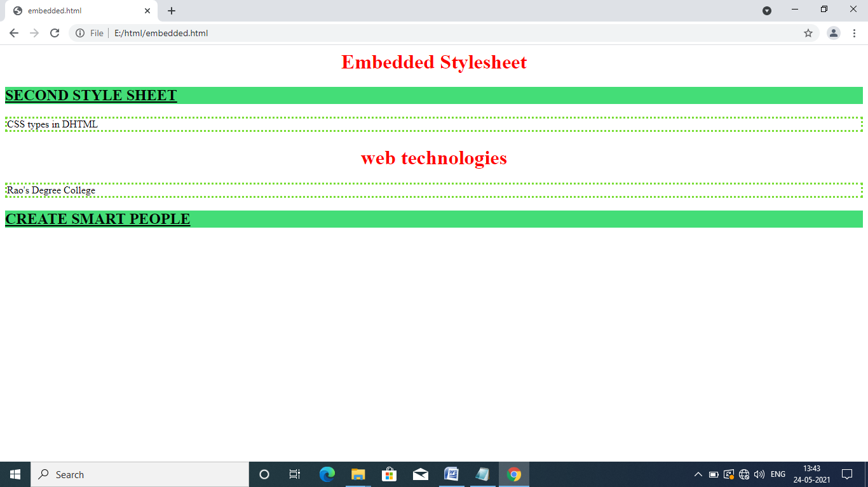

1. ***EXTERNAL LINKING STYLE SHEET:***

Styles can also be defined in multiple documents, required properties in an external file with extension .**CSS .**  The stylesheets can be accessed by linking to the desired HTML file using link tag with **“rel(relation)”**  attribute.

The general form of external linking style sheet is as follows:

***Syntax:***

<link rel=“stylesheet” href=“url”>

The above syntax is placed in HEAD section only.

***Ex:*** **Save as extxss.css**

ul ul{color:red;background-color:pink}

em{border-style:dotted;border-color:blue}

li em{color:green; background-color:#ffaa77}

h1{text-align:center;text-transform:uppercase}

**Save as extcss.html:**

<html>

<head>

<link rel="stylesheet" href="extcss.css">

</head>

<body>

<h1> shopping list for <em>Monday</em></h1>

<ul>

<li>Milk</li>

<li>Bread

<ul>

<li>White Bread</li>

<li>Wheat Bread</li>

</ul>

</li>

<li>Rice</li>

<li>Potatoes with <em>Mushrooms</em></li>

</ul> </body> </html>

**Output:**

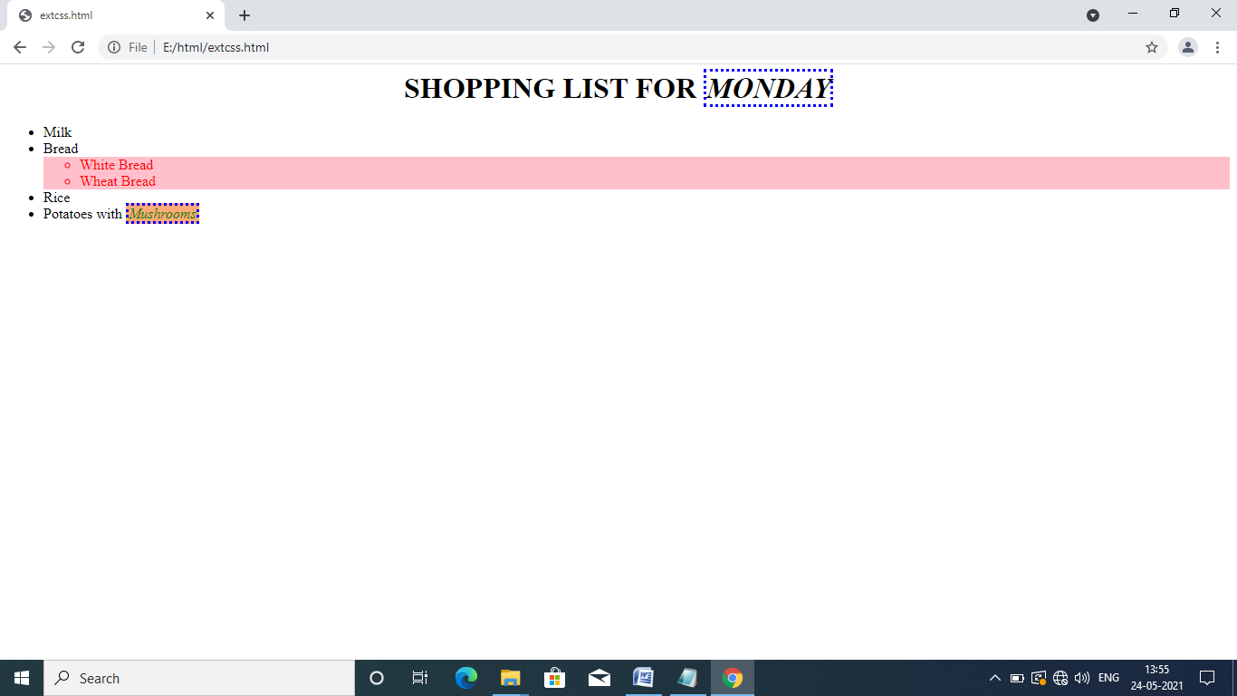

1. **Positioning Elements:**

Before CSS, controlling the positioning of elements in an HTML document was difficult- the browser determined positioning. CSS introduced the **position** property and a capability called **absolute positioning,** which gives authors greater control over how document elements are displayed.

**Ex:**

<html>

<head>

<title>Absolute positioning </title>

</head>

<body>

<p><img src="flower1.jpg" style="position:absolute;top:0px;left:0px" alt="first

positioned image"></p>

<p style="position:absolute;top:50px;left:50px;font-size:20pt;color:blue">Positioned

Text</p>

<p><img src="flower2.jpg" style="position:absolute;top:50px;left:50px" alt="second

positioned image"></p>

</body>

</html>

**Output:**

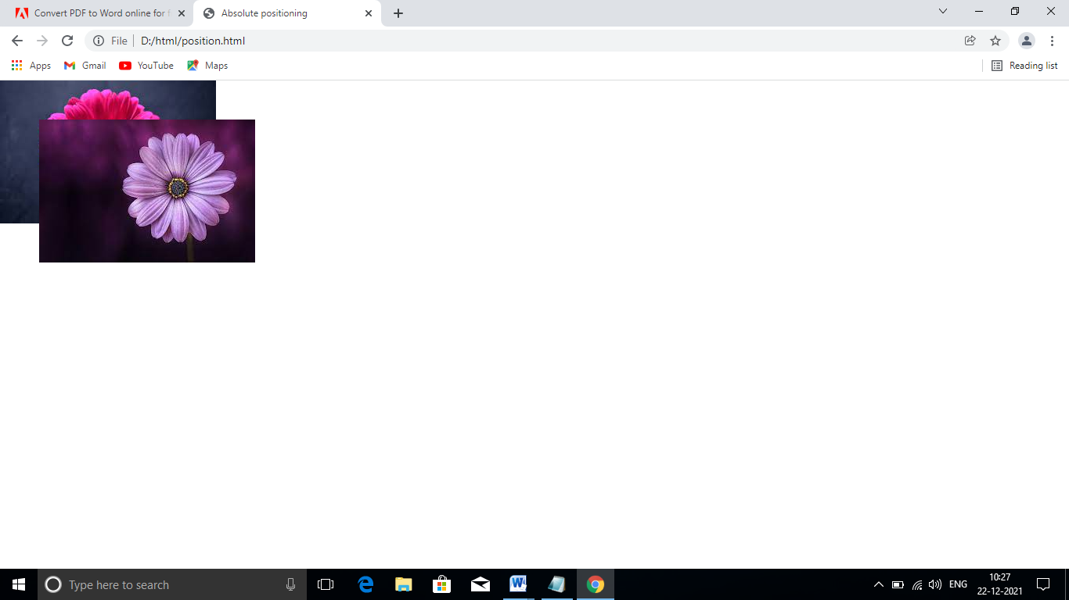

In the above program, position the first image element( flower1.jpg) on the page. Specifying an element’s position as absolute removes the element from the normal flow of elements on the page, instead positioning it according to the distance from the top. Left, right or bottom margins of its containing block-level element. Here , we position the element to be 0 pixels away from both the top and left margins of the <p> element.

In above program flower2.jpg displays in front of the flower1.jpg . Absolute positioning is not the only way to specify page layout. Not only absolute positioning, in CSS , we follow relative positioning, in which elements are positioned relative to other elements.

1. **CSS Backgrounds:**

CSS provides control over the element backgrounds. In previous we apply background-color property. CSS also can add background images to documents.

In CSS, we apply background-image , here we use background-image property, specifies the image URL for the image flower1.jpg in the format url ( file location) .

**Ex:**

<html>

<head>

<title> Background-image </title>

<style>

body{ background-image:url(flower1.jpg);

background-position: top left;

background-repeat:no-repeat;

background-attachment:fixed}

p{font-size:large;color:red;font-family:Calibri (Body)}

</style>

</head>

<body>

<p> This example uses the background-image, background-position and styles to

place the image in the bottom, right corner of the page.</p>

</body>

</html>

**Output:**

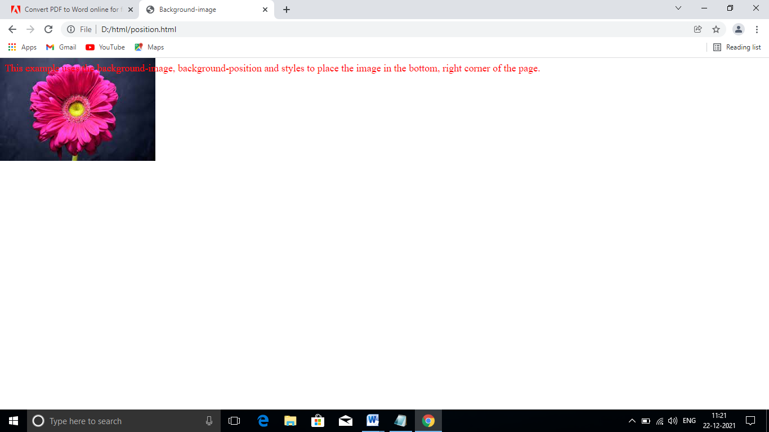

In above program, we use different properties, i.e., the background-position property places the image on the page. The keywords are top, left, bottom, and center and right are used individually or in combination for vertical and horizontal positioning.

The background-repeat property controls the tiling of the background image.Tiling places multiple copies of the image next to each other to fill the background. Here we set no-repeat to display only one copy of the background image. But we set repeat property to tile the image vertically and horizontally . repeat-x to tile the image only horizontally or repeat-y to tile the image only vertically.

The final property setting, background-attachment:fixed , fixes the image in the position specified by background-position.

1. **Element Dimensions:**

In addition to positioning elements, CSS rules can specify the actual dimensions of each page element. In CSS we set the dimensions of positioning elements of the page, use div tag. It is a container tag. This div element illustrates how to set the width of an element on screen.

**Ex:**

<html>

<head>

<title> Box dimensions</title>

<style>

div {background-color:#ffccdd;margin-bottom:1em}

</style>

</head>

<body>

<div style="width:20%"> Here is some text that goes in a box which is set to stretch

across twenty percent of the width ofv the screen</div>

<div style="width:80%;text-align:center"> Here is some CENTERED text that goes in a

box which is set to eighty percent of the width of he screen</div>

<div style="width:30%;overflow:scroll"> This box is only thirty percent of the width .

Overflow property se t to scroll the box</div>

</body>

</html>

**Output:**

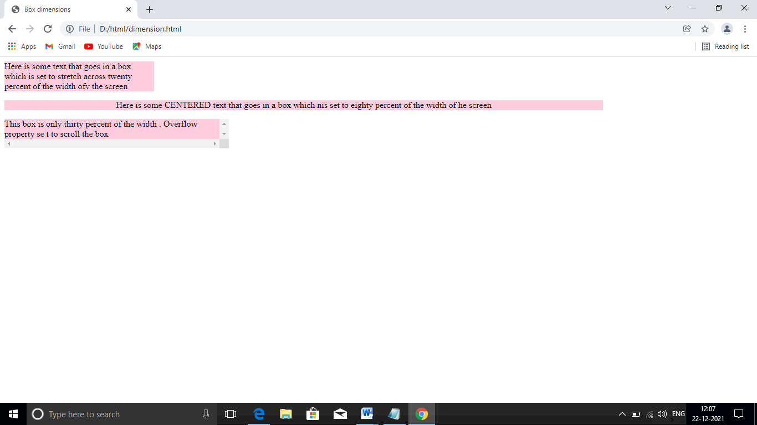

Most elements are left-aligned by default; however, this alignment can be altered to position the element elsewhere. Other values for text-align property include left and right. In above we use width property it indicates that the div element should occupy twenty percent of the screen width. We set the overflow property to scroll, a setting that adds scrollbars if the text overflows the boundaries.

1. **Text flow and the box model:**

A browser normally places text and elements on screen in the order in which they appear in the HTML document. However, as we have seen with absolute positioning, it is possible to remove elements from the normal flow of text. Floating allows you to move an element to one side of the screen; other content in the document then flows around the floated element.

In addition, each block-level element has a virtual box drawn around it, based on what is known as the box-model.

**Ex:**

<html>

<head>

<title> text flowand the box model </title>

<style>

div{ background-color:#ccffaa;margin-bottom:.5em;

font-size:1.5em;width:50%}

p{text-align:justify}

</style>

</head>

<body>

<div style="text-align:center"> Dietal & Dietal</div>

<div style="float: right; text-align:right">Corporate training and

publishing</div>

<p> It is an internationally recognised corporate training and publishing

organization specializing in programming languages, Internet world wide

web technology and object technology education. The company provides

courses on java,C++, Visual basic ,c etc</p>

<div style="float:right; text-align:right">Leading-edge programming text

books</div>

</body> </html>

**Output:**

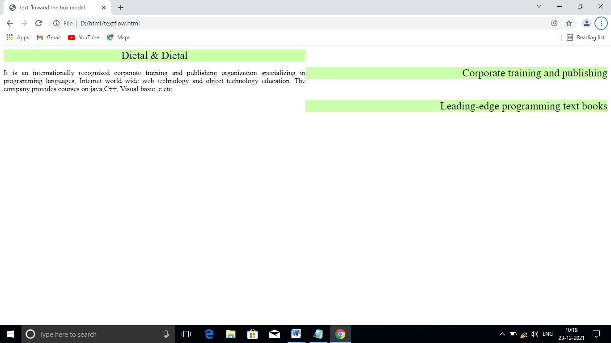

In addition to text, whole elements can be floated to the left or right of content. This means that any nearby text will wrap around the floated element. In above example, we float a div element to the right side of the screen.

Margins for individual sides of an element can be specified by using the properties margin-top, margin-right, margin-left and margin-bottom.

**Ex:**

<html>

<head>

<title> box model</title>

<style>

body{ background-color:yellow}

div{text-align:center;

margin-bottom:.5em}

.thick{border-width:thick}

.thin{border-width:thin}

.medium{border-width:medium}

.groove{border-style:groove}

.red{border-color:red}

.blue{border-color:blue}

</style>

</head>

<body>

<div class="thick groove"> This text has a border</div>

<div class="thin groove"> This text has a border</div>

<div class="thin red groove">This text has a thin red line.......</div>

<p class="medium groove red">This paragraph has a red border</p>

<p class="thick groove blue"> This paragaraph has a blue color</p>

</body>

</html>

**Output:**

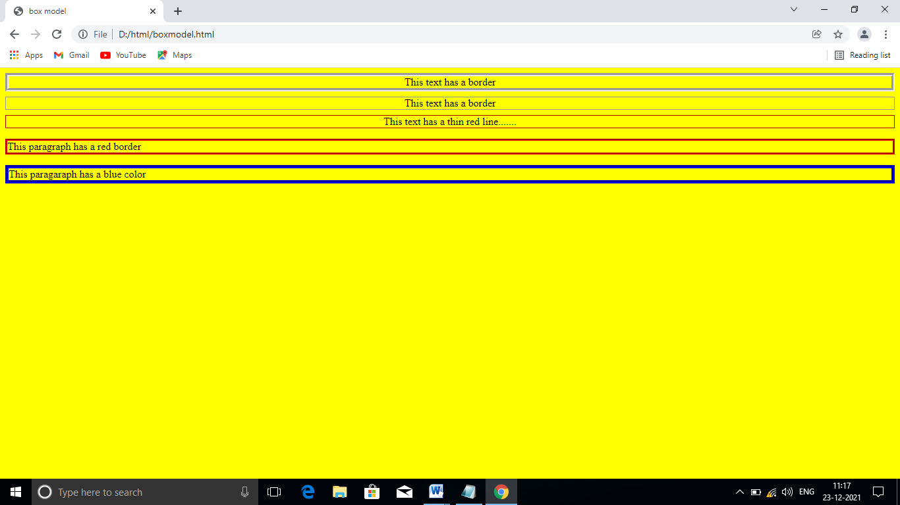

In above program, we set three properties-border-width, border- color and border-style. The borer-width property may be set to any valid css length or to the predefined value of thin, thick or medium. The border-color property sets the color. The border-styles are dotted, solid, dashed, double, groove, ridge, inset and outset.

1. **User style sheets:**

Users can define their own style sheets to format pages based on their preferences. For example, people with visual impairments may want to increase the page’s text size. Web page authors need to inadvertently override user preferences with defined styles.

In below example, the font-size is set to 30pt for all <p> tags that have class ***note*** applied to them.

**Ex:**

<html>

<head>

<style>

.note{ font-size:30pt;

color:yellow;

background-color:#22ddaa}

</style>

</head>

<body>

<p> thanks for visiting for my website. I hope u enjoy it.</p>

<p class="note"> please note . This site will be soon </p>

</body>

</html>

**Output**:

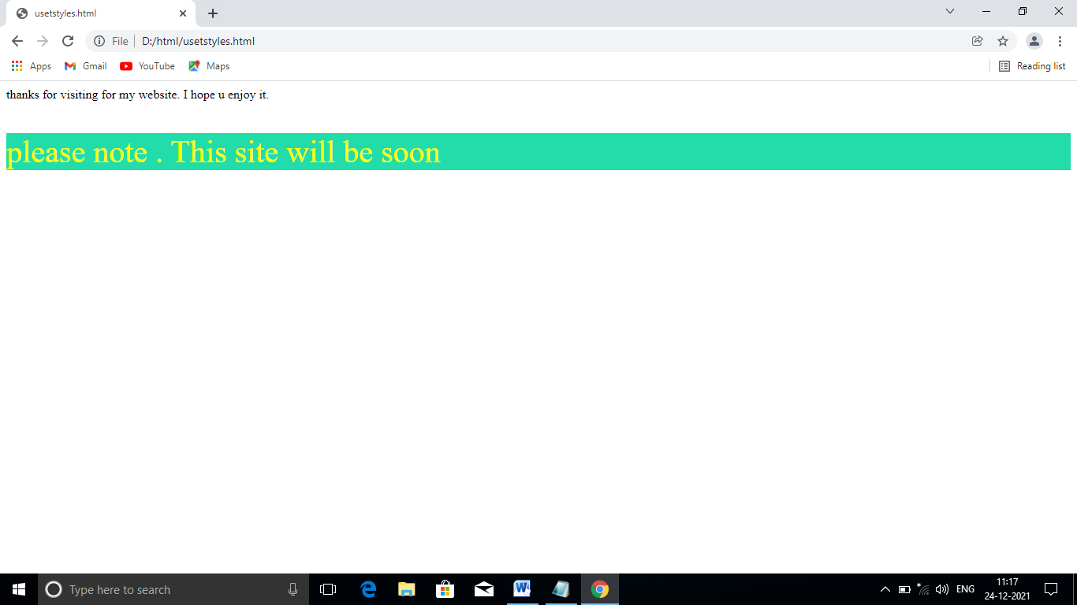

User styles sheets are external styles heets. In above example, shows a user style sheet that sets the body’s font-size, color to yellow and background-color to hexadecimal coding. User style sheets are not linked to a document.: rather, they are set in the browser options. Finally displays the web page from above example program with the user style sheet from example applied.